LAB 10 OBJECTIVE
Practice loops.

LAB
1.
Write a program that prompts the user to enter a number and prints a square of stars using the number to determine its width. Eg: if the user enters 5 for number the square should have 5 stars across and down as follows:
*****
*****
*****
*****
*****
Save as L10a.c (1 mark)

2.
Write a program which uses 2 for structures to print the following patterns:
*
**
***
****
*****
******

******
*****
****
***
**
*
Save as L10b.c (5 marks)

3. Write a program with the following menu:
A Square
B Triangle Increase
C Triangle Decrease
Please choose:
Using a switch statement print out the appropriate shape.
If the user chooses Square prompt them for the size of the square.
Triangles are 6 rows long and 6 columns wide.

Save as L10c.c (4 marks)

Lab 11

Objective:
To write programs using library functions.
For programs using math.h please use the following:
#define _USE_MATH_DEFINES
#include <math.h>
- Using the math.h library write a program that reads the radius of a sphere and prints its volume. Note: Volume of a sphere = 4/3π r³ Remember your typecasting!
Save as lab11a.c (1 mark)
2. Using the math.h library write a program which reads in four radii of spheres and prints the surface area and volume of the spheres in tabular format as shown below:
Sphere Radius Surface Area Volume
1 1 12.57 4.19
2 1 12.57 4.19
3 1 12.57 4.19
4 1 12.57 4.19

Remember your typecasting!
Note: Surface area of a sphere = 4 π r² , Volume of a sphere = 4/3π r³
Save as lab11b.c (3 marks)
(1 mark
3. Write a program which prompts the user as follows:
S Sine
C Cosine
T Tan
Please enter: C
Please enter an angle: 45
Cosine 45 = 0.53
Save as lab11c.c (4 marks)

- Modify last week’s program Lab1c.to use sentinel controlled repetition. The main function should prompt the user with the following menu:
A Print Square
B Print Triangle Increase
C Print Triangle Decrease
Q Exit
If the user selects A then the main function should prompt the user for the dimension of the square.
Save as lab11d.c (2 marks)

Lab 12

Objective:
Write programs using functions.
Note Functions can be called many times
Programs can have many functions
Functions can be void and accept different types of variables
Functions can return variables to stdout or to be saved in a variable

- Write and test a function called computeArea which returns the area of a circle with a given radius r. Note area = PI* r²
Save as L12a.c. (1 mark)
- Write a program with two functions ComputeArea which calculates the area of a circle and ComputeCircum which calculates the circumference of a circle (circum = 2*PI*r). The main function should prompt the user for the radius of five different circles and print the Area and circumference in tabular form as follows:
Circle Radius Area Circumference
1 1 3.14 6.28
2 1 3.14 6.28
3 1 3.14 6.28
4 1 3.14 6.28
5 1 3.14 6.28
Save as L12b.c (1 marks)
- Write a function fillCharacter which is passed a number and a character. The function should print on the left hand side of the screen a square filled with the passed character. The side of the square is determined by the passed number eg:
for the passed values 4 and & the square should look like:
&&&&
&&&&
&&&&
&&&&
Save as L13c.c (3 marks)
- Define a function called hypotenuse which is passed two floats and returns a float. The function calculates the length of the hypotenuse of a right angled triangle when the other two sides are given. Using a loop determine the hypoteneuse of the following triangles :
Triangle 1 side1 side2
1 3.0 4.0
2 5.0 12.0
3 8.0 15.0
Note 1: hypoteneuse = sqrt(side1² + side2² )
Note 2: It is not necessary to print the answers in tabular format.
Save as L12d.c (3 marks)

5.
Using L2d.c from last week write a program which contains three functions printSquare, printTriangleInc and printTriangleDec which prints out the shapes described in last week’s lab.
Using sentinel controlled repetition the main function should prompt the user with the following menu:
A Print Square
B Print Triangle Increase
C Print Triangle Decrease
Q Exit
If the user selects A then the main function should prompt the user for the dimension of the square and pass this data to the function printSquare.
If the user selects B or C then the main function should call the function printTriangleInc or printTriangleDnc.
Save as lab12d.c (2 marks)

Lab 13

Objective:
Write programs using functions. Revise loops.

- Write a function integerPower(base, exponent)that returns the value of base^{exponent}
For example integerPower(3,4) = 3*3*3*3. Assume that exponent is a positive nonzero integer, and base is an integer. The function integerPower should use for or while to control the calculation.
Do not use any math library functions.
Using the integerPower function write a complete program using sentinel controlled repetition which
runs as shown below:
Please enter an exponent (0 to end): 3
Please enter a base: 2
2 ^ 3 = 8
Please enter an exponent t(0 to end): 4
Please enter a base: 3
3 ^ 4 = 81
Please enter an exponent (0 to end): 0
Save as L13a.c (3marks)

- Write a program which calculates the length and slope of lines using the formulae:
Slope = (y2 – y1) / (x2 –x1) and
Line length = sqrt( (x2 –x1)² + (y2-y1)²))
The user should be prompted for the values of x1, x2, y1and y2 from main().
Two functions should be called calcLength and calcSlope.
calaLength should return the length of the line to main and calcSlope should return the slope of the line to main().
All values for x and y should be floats.
Using a loop the program should prompt the user for four different lines.
You can use the following values to test your program:
X1 | X2 | Y1 | Y2 | Slope | Length
0 | 1 | 0 | 0 | 0 | 1
0 | 1 | 0 | -1 | -1 | 1.41
-2 | 1 | 0 | 0 | 0 | 3
0 | 1 | 0 | 1 | 1 | 1.41
Save as L3b.c. (3 marks)

- Write a program which has a function named 'average'. The function should compute and return the average of 2 passed integers. Use type casting!
Save as L13c.c (2 marks)
- Write a complete C program with a function that will calculate and display the real roots of the quadratic equation
ax² + bx +c
using the quadratic formula:
x = (-b +/- sqrt(b²-4ac))/2a
Assume that a,b,c,x1 and x2 are floats and that b² > 4ac so that the calculated roots will all be real.
a,b,and c should be input from main and passed to the function.
Use a loop to test the program with the following inputs:
a b c
2 6 1
3 3 0
1 3 1
Note the output does not need to be in tabular format.
Your answers should be -0.18 and -2.82, 0 and -1, -0.38 and -2.62
Save as L13d.c (2 marks)

Lab 14

Objective:
Write programs using functions.
- Write and test a boolean function called IsOdd which determines whether a passed integer is odd or not. Use a loop and test exactly 5 numbers.
Remember to use bool
You can use <stdbool.h> if saving as .c
Ensure the code works for negative numbers.
Save as L14a.cpp. (3 marks)

- Write and test a boolean function called IsUppercase which determines whether a passed character is uppercase or not. ( Lies between A and Z). The user should be prompted for the charcter from main and it should be passed to IsUppercase. Using sentinel controlled repetition the program should run until the user enters the sentinel which should be ‘$’. Remember hex numbers need 0x
Save as L14b.cpp. (3 marks)

- Write a function toLower which converts an uppercase letter to lowercase.
Modify L14b.cpp and include toLower to have an option where the user can opt to convert an uppercase letter to lowercase.

Eg:
Please enter a character ($ to end): A
Letter is uppercase.
Would you like to convert A to lowercase (Y/N): Y
Letter is now a.

Please enter a character ($ to end): e
Letter is not uppercase.

Please enter a character ($ to end): $

Save as L14c.cpp (1 marks)
- Write a program which contains five functions printSquare, printTriangleInc and printTriangleDec which prints out the shapes described in last week’s lab.
Using sentinel controlled repetition the main function should prompt the user with the following menu:
A Print Square
B Print Triangle Increase
C Print Triangle Decrease
D Calculate Line Slope
E Calculate Line Length
Q Exit
If the user selects A then the main function should prompt the user for the dimension of the square and pass this data to the function printSquare.
If the user selects B or C then the main function should call the function printTriangleInc or printTriangleDnc.
If the user chooses D or E then the mail function should prompt the user for the line segment points x1,y1 x2,y2 and pass these points to the functions.
Save as Lab14d.c

Lab 15

Objective:
Write programs using arrays.

- Write a program which:
a) initialises an integer array of 5 elements to '0'
b) prints the array on screen
c) modifies the array to contain the numbers 1,2,3,4,5. You must use a loop.
d) prints the array again.
e) multiplies each element by 2.
d) prints the array again.
Save as L15a.cpp (2 marks).
- Write a complete C++ program which:
- Declares three floating point arrays height[ ], base [ ] and area [ ].
Each of the arrays must be able to hold three elements each.
- Using a for loop prompt the user to enter values for the height and base of the three triangles.
- Using a for loop calculate the area for each of the triangles.
- Using a for loop output the result as shown below.

Triangle Height Base Area
1 3.0 4.0 6.0
2 5.0 12.0 30.0
3 8.0 15.0 60.0

Save as L15b.cpp. (2 marks)
- Use an array and a for loop to rewrite the following program:
A garage charges €2 minimum for up to 2 hours parking. An additional €2.50 is charged for each hour or part of after that. The maximum fee for any period is €14.00.
Write a program that will calculate & print the parking charges for each of 3 customers. You should enter the hours parked for each customer. Your program should print the result as shown below and calculate the totals. The program should use a function called calculateCharges to determine the charge for each customer.
Car Hours Charge
1 1.5 2.00
2 3 4.50
3 24 14.00
Total 28.5 20.50
Save as L15c.cpp. (6 marks)

Lab 16

Objective:
Write programs using arrays.

1. Write a complete C++ program which finds the volume of three cylinders.
Note volume = PI r²h
where r = radius of the cylinder,
h = height of the cylinder.
Three arrays should be used called volume, height and radius to store the area, height, and radius of each of the cylinders.
The program should:
- Declare three arrays of doubles called volume, height and radius .
- Use one for loop to scan in arrays height and radius. (Remember to use %lf for double )
- Use a loop to find the volume of the cylinders and store the answers in array volume.
- Use a loop to print all arrays to stdout in tabular format as shown below.
Cylinder Height Radius Volume
1 3.0 4.0 150.80
2 1.0 2.0 12.57
3 6.0 1.5 42.41

Figure 1(b)

Save as L16a.cpp. (1 mark)
2.
A class of 4 students took two quizzes and their results (integers) are available.
Write a program which:
- prompts the user to enter the quiz results for each student into two arrays
StudentMark1 and StudentMark2…. remember they are integers.
- Finds the average quiz result for each quiz – averageQuiz1 and averageQuiz2 and print to stdout…. Remember to typecast.
- Finds the average quiz mark for each student.
Sore these averages in an array called studentAverage….remember to typecast.
- Prints the studentAverages
- An overall average mark of 70% is required to gain a distinction.
Using a for loop count how many students have achieved a distinction and print the number to stdout.
- Find the student with the highest overall average mark and print the mark and student index to stdout.
Save as L16b.cpp. (6 marks)
3.
Modify lab 14d so that:
The line coordinates are stored in two arrays x[2] and y[2].
Alter the menu system so that the user is presented with the following sequence of menus:
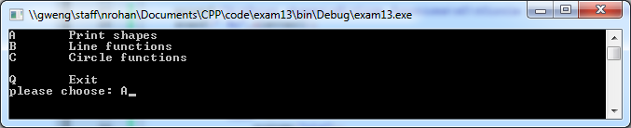
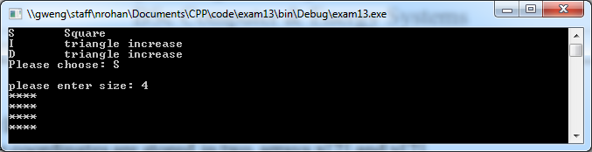
OR
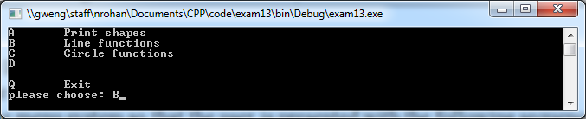
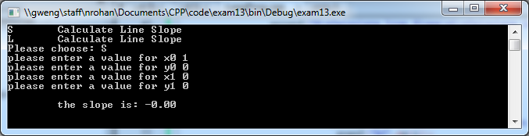

OR
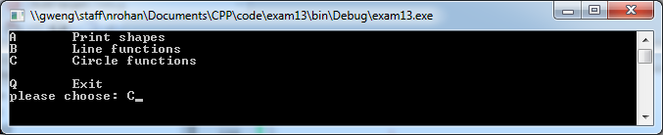
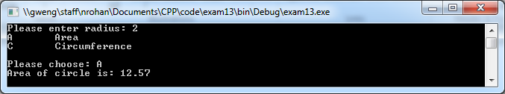

You can use
system("cls") and include header file stdlib.h to clear the screen and
getch() and include <conio.h> to get the screen to wait until there is a user input.

Save as L16c.cpp ( 3 marks)

Lab 17

Objective:
Write programs
- To implement a stack
- strings
- Write a complete C++ program to implement a stack in using an array.
Reserve 100 locations for the stack.
The user should be able to decide what size the stack will be. It cannot be greater that 100.
Write the following functions:
bool isStackFull(int s) a Boolean function to see if the stack is full. Pass the stackSize is passed to the function.
bool isStackEmpty() a Boolean function to see if the stack is empty
void push(int e) a function to push an integer onto the stack. The integer to be pushed is passed.
int pop() a function to pop an integer from the stack. The stack element is returned.
void displayStack() a function to display the contents of the stack from the top to the bottom.

The stack array and a variable top indicating the location of the top of the stack should be global variables.
A sample run of the program is given below
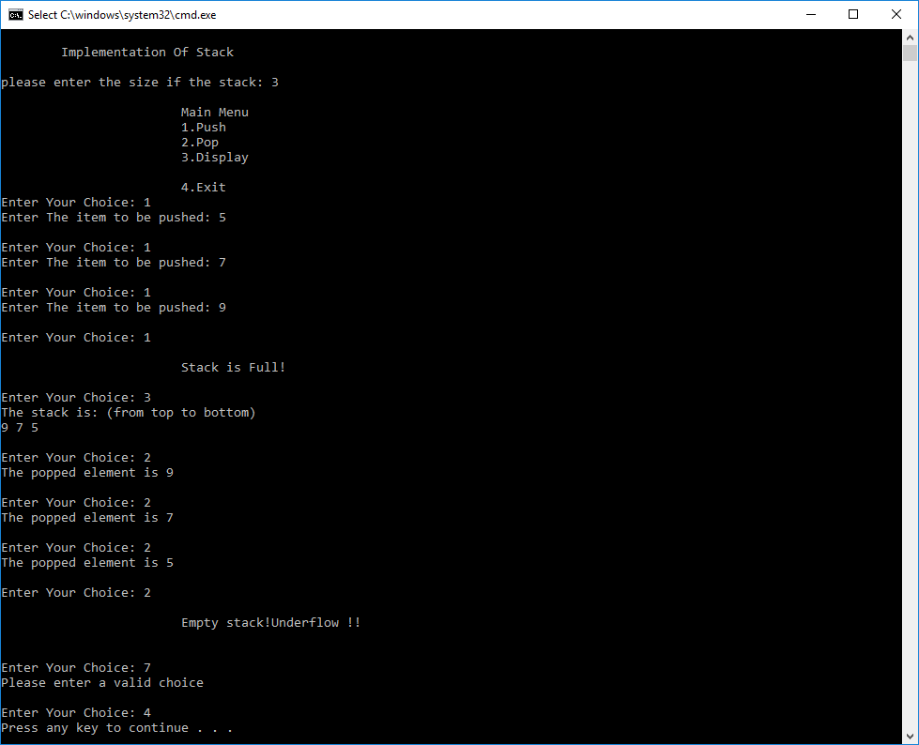
Save as L1a.cpp (7 marks)

- Write a program which :
  - declares and initialises a string str1 to “Hello”
  - declares a string str2 with 20 characters.
  - prompts the user to enter their name and stores their name in str2
  - prints the strings str1 and str2 to stdout.
  - prints the strings str1 and str2 in ASCII to stdout.
Save as L17b.cpp (3 marks)
Revision Lab
Attempt all sections. Time allowed 1.5 hours.

Question:
A record of how many people visit a restaurant on each day of the week is being taken.

Write a program which:
- Declares an integer array of 7 elements called customers.
- prompts the user to enter the number of customers for each day into the array customers.
(The number of customers should be a number between 0 and 100)
- Print the number of customers for each day to stdout.
- Finds the average number of customers per day and prints it to stdout.
Save as 'exam1.cpp'.

Write and test a boolean function called IsInRange which determines whether a passed integer lies within
the range 1 … 15 inclusive. The user should be prompted for the integer from main and it should be passed to
IsInRange. The message number is in range or number not in range should be printed from main.
Save as Exam2.c
Change the above program to use sentinel controlled repetition the program should run until the user enters the sentinel which should be -1.
Eg:
Please enter an integer (-1 to terminate): 4
4 is in range.
Please enter an integer (-1 to terminate): 24
24 is not in range.

Please enter an integer (-1 to terminate): -1
Save as 'Exam3.c'.
Question 2

Write a function that converts an uppercase letter to lowercase. Use the following function header:

char toLowerCase(char ch)
If the character is not an uppercase letter, the method simply returns the character itself. For example, toLowerCase('B') returns b and toLowerCase('5') returns 5.

Write a test program that prompts the user to enter a character, invokes the function, and displays its return value.

Enter a char ($ to end): A
a
Enter a char ($ to end): 3
3
Enter a char ($ to end): $

Save as 'Exam4.c'.

